Terraform Task 4

1. Execute the script shown in the video.
Hands-on: Specify Terraform Provider Version
Step 1: Create a new folder
Run: mkdir provider-version-demo
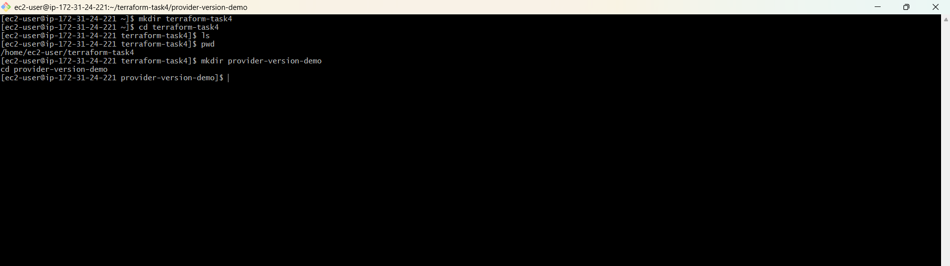
Step 2: Go inside the folder
cd provider-version-demo
Your prompt should now be:
PS C:\Users\sriva\Desktop\Terraform-provider\provider-version-demo>
Step 3: Open this folder in VS Code
code .

Step 4: Create versions.tf
In VS Code, create:
versions.tf
Add:
terraform {
required_providers {
local = {
source = "hashicorp/local"
version = "2.5.2"
}
}
} 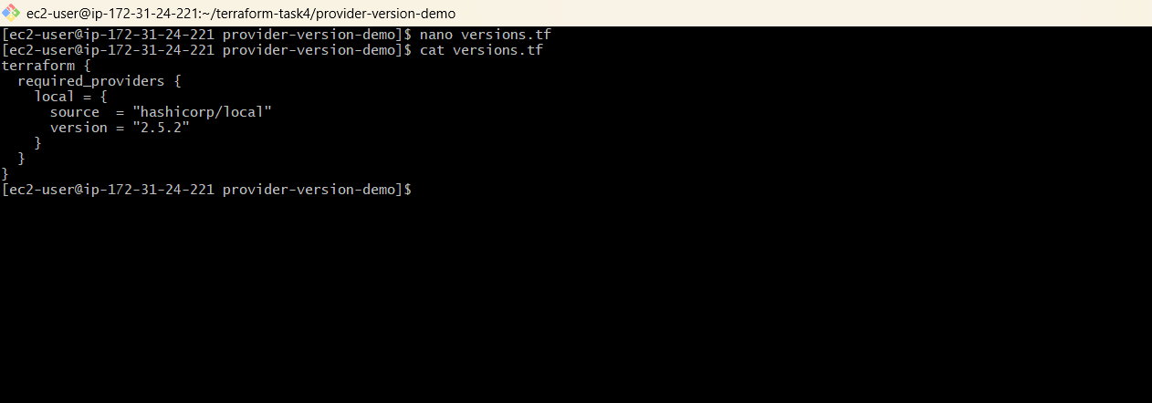

Step 5: Create main.tf
Create:
main.tf
Add:
provider "local" {}
resource "local_file" "example" {
filename = "example.txt"
content = "Hello from Terraform"
}
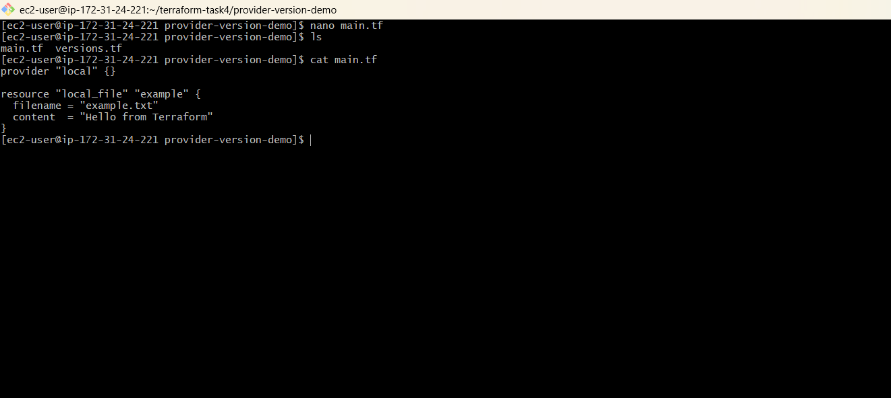

Step 6: Initialize Terraform
In the terminal:
terraform init
Terraform will download the local provider version 2.5.2. 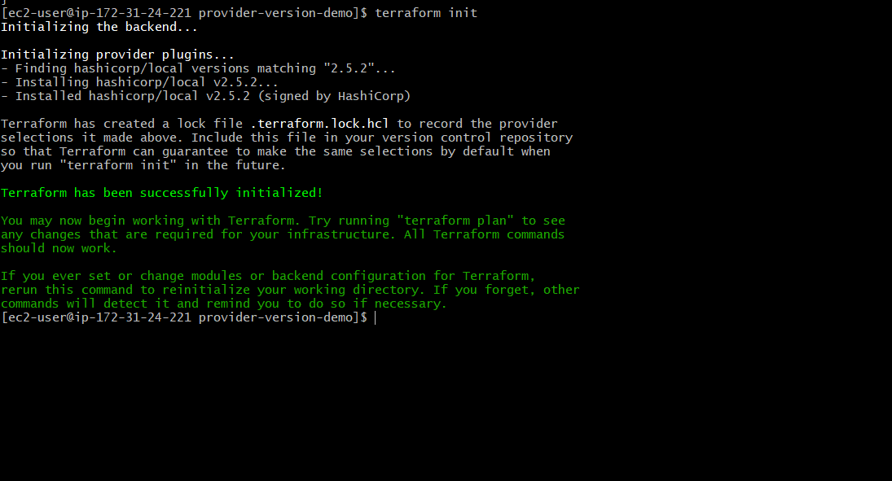

Step 7: Verify the provider
terraform providers
You should see:
hashicorp/local
2.5.2
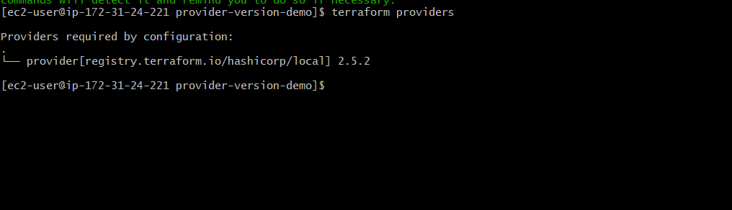

Step 8: Apply
terraform apply
Enter:
yes 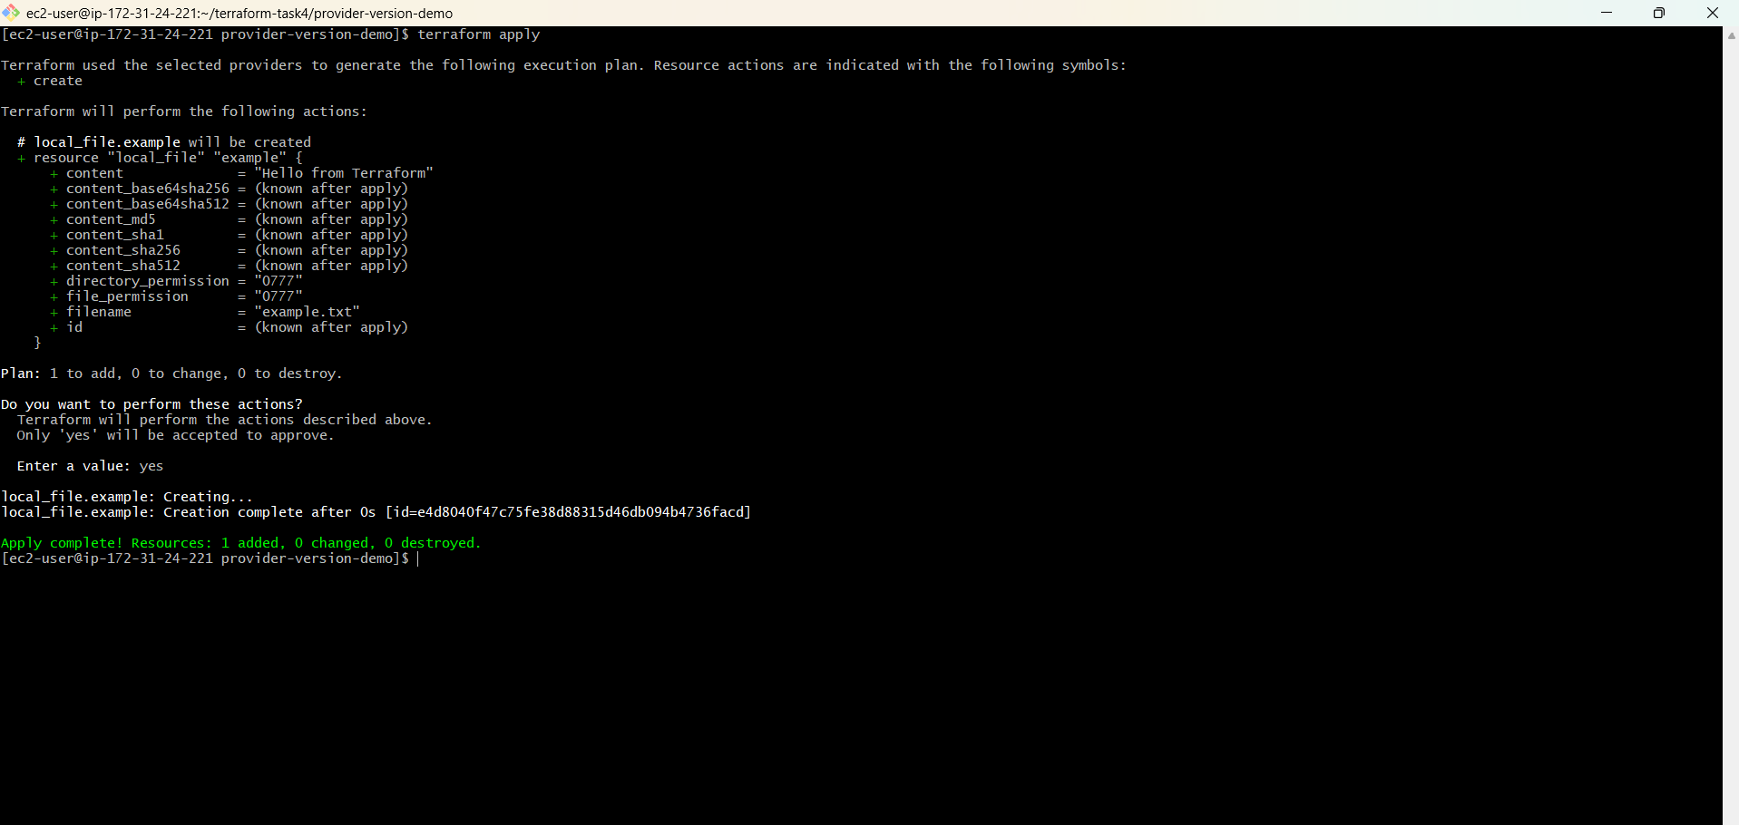
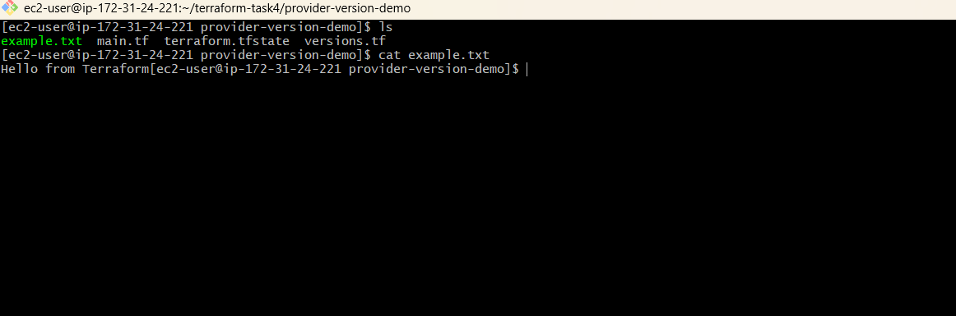

Step 9: modified version
Get-Content example.txt
You should get:
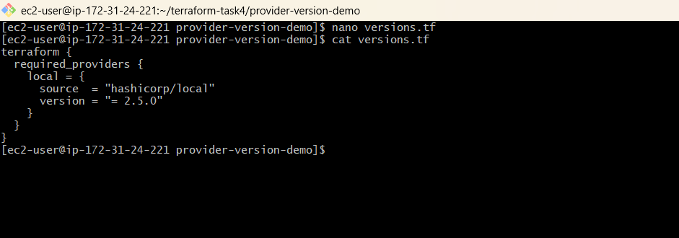

Terraform Provider Version Constraints – Hands-on
1. Go to your folder
cd C:\Users\sriva\Desktop\Terraform-provider\provider-version-demo
2. Test = Exact version
In versions.tf:
version = "= 2.5.0"
Run:
terraform init -upgrade
terraform providers 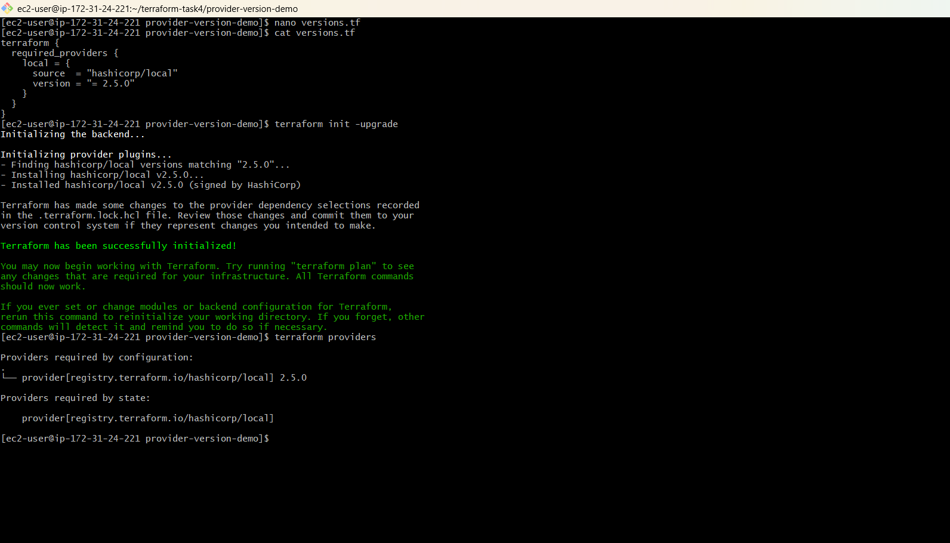

3. Test != Not equal
Change to:
version = "!= 2.5.0"
Run:
terraform init -upgrade
terraform providers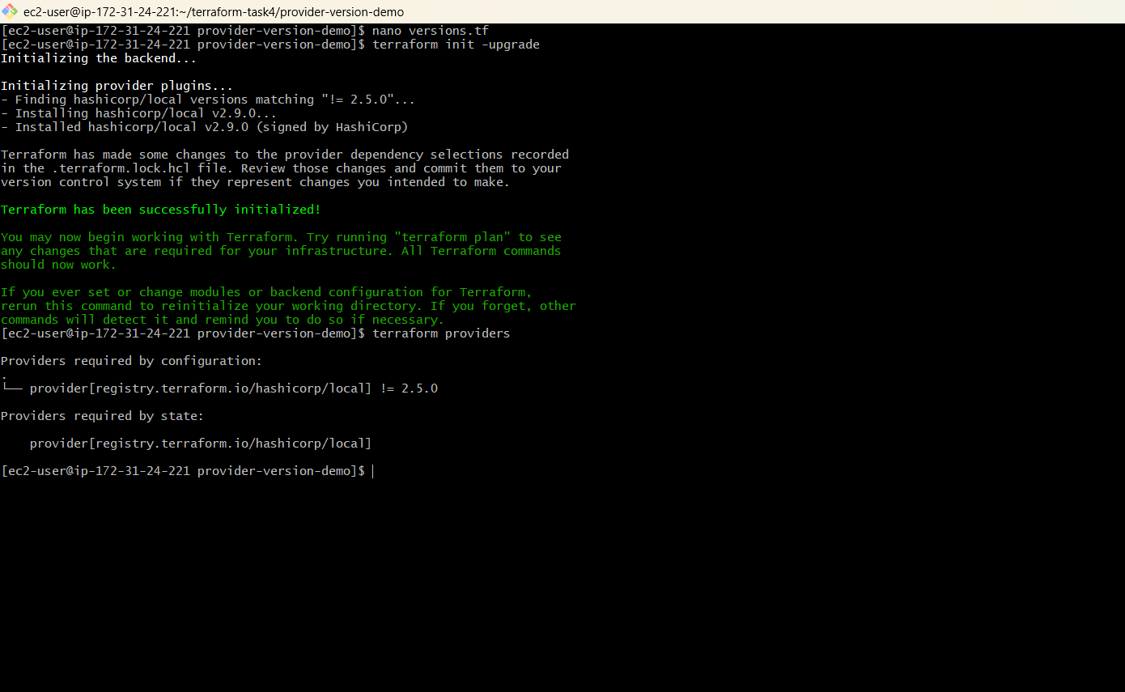

4. Test > Greater than
version = "> 2.5.0"
Run:
terraform init -upgrade
terraform providers 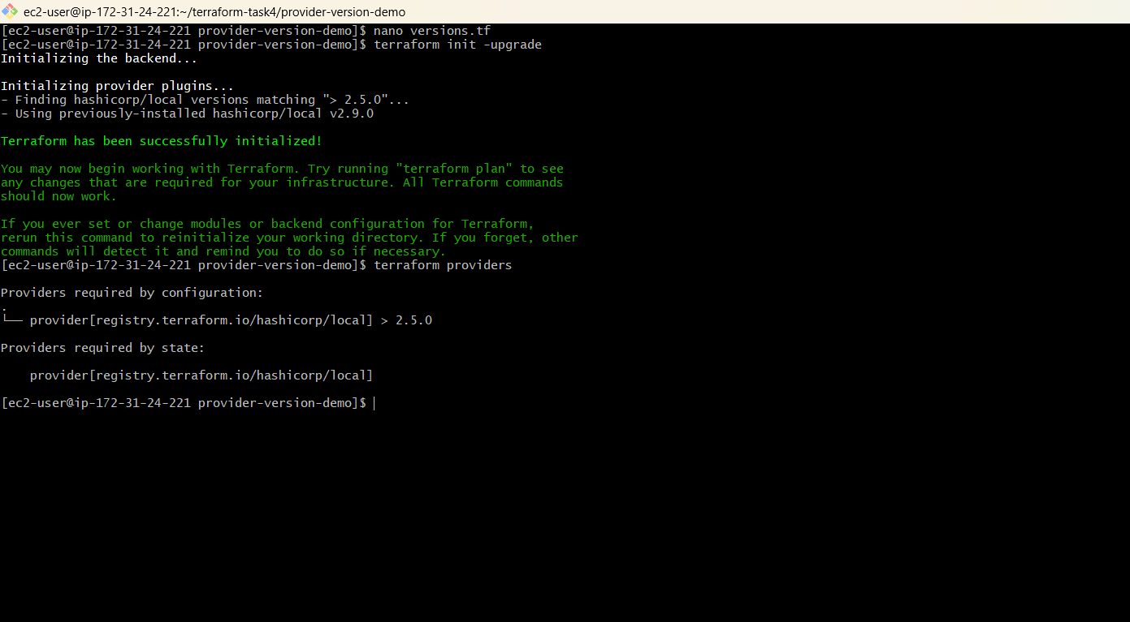

5. Test >= Greater than or equal
version = ">= 2.5.0"
Run:
terraform init -upgrade
terraform providers 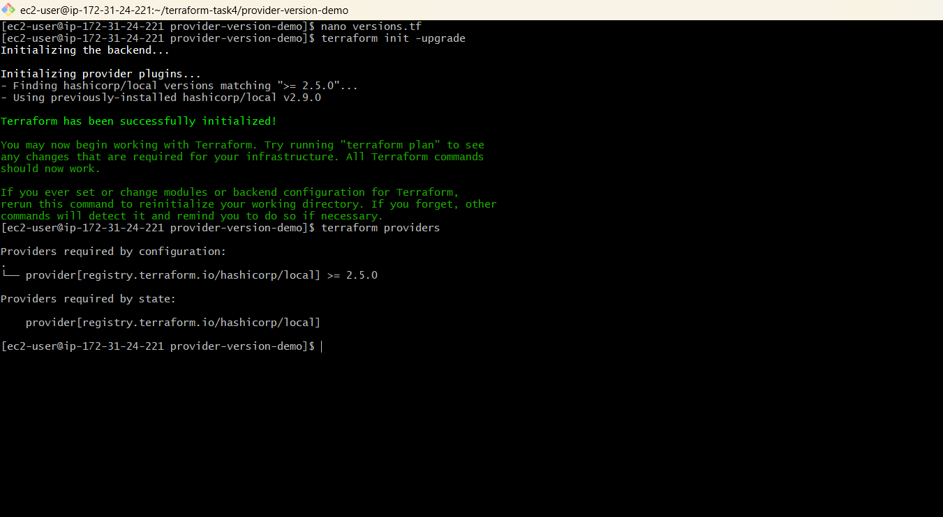

7. Test <= Less than or equal
version = "<= 2.5.0"
Run:
terraform init -upgrade
terraform providers 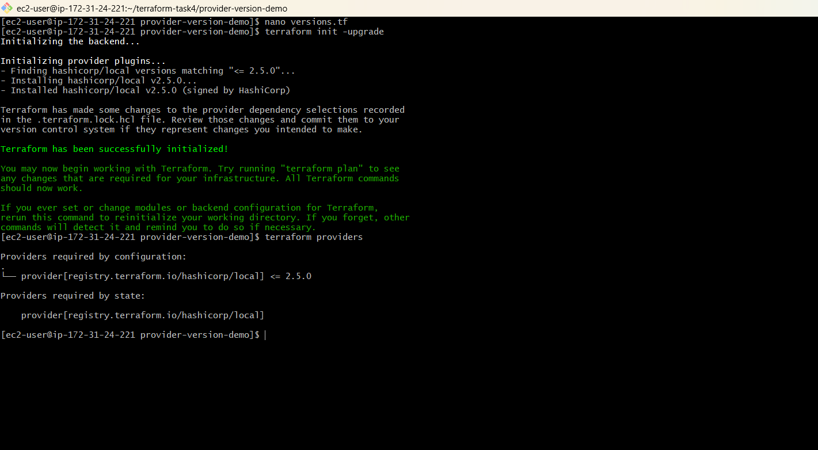

8. Test ~> Pessimistic constraint
version = "~> 2.5"
Run:
terraform init -upgrade
terraform providers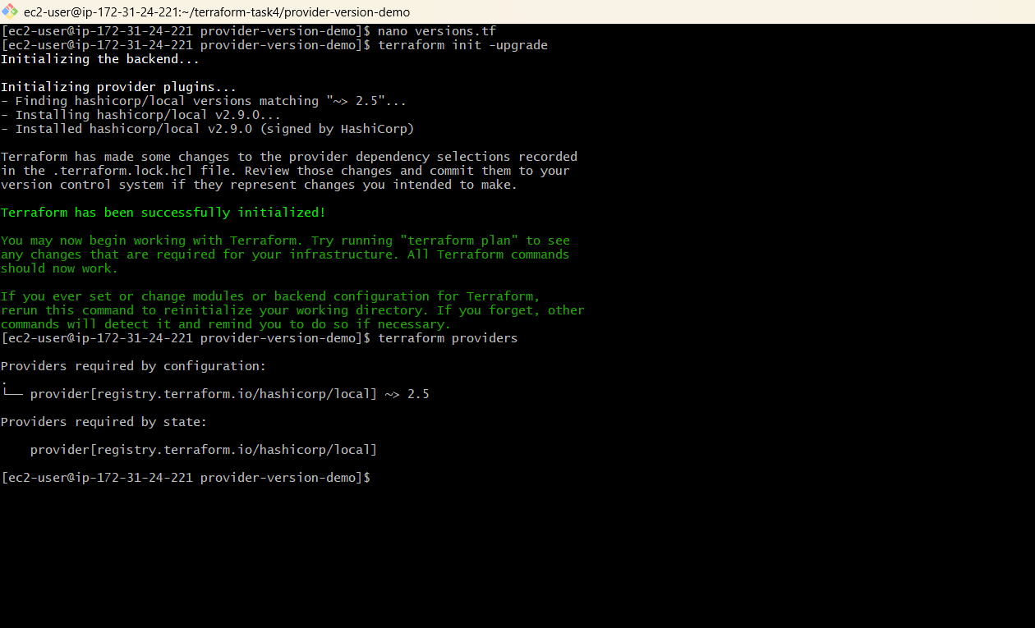

  - Terraform Data Source — Hands-on
We’ll use the local provider and read an existing file using a data source.
1. Create data.tf
data "local_file" "example" {
filename = "example.txt"
}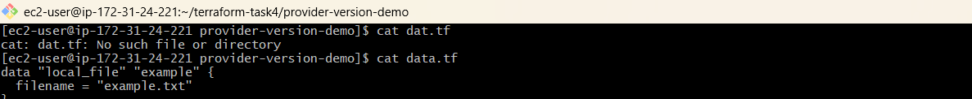
2. Keep main.tf
provider "local" {}

resource "local_file" "example" {
filename = "example.txt"
content = "Hello from Terraform"
}
3. Initialize
terraform init
4. Apply
terraform apply
This creates:
example.txt 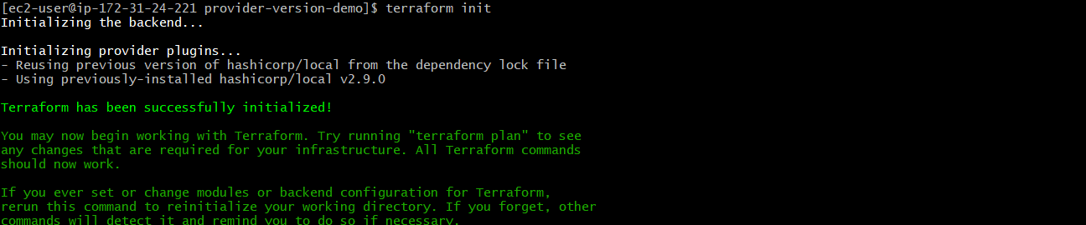
5. Read the file using Data Source
Terraform init
terraform apply
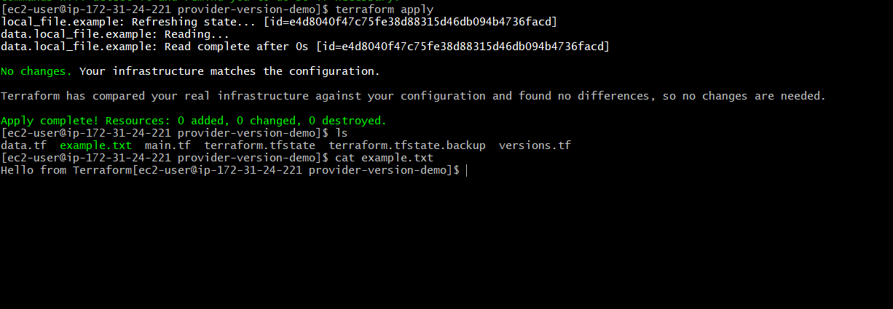

  - Terraform Meta-Arguments → count and for_each
Step 1 — Go to your Terraform folder
In PowerShell:
cd C:\Users\sriva\Desktop\Terraform-provider
Step 2 — Create a new folder
mkdir meta-arguments-demo
Go inside:
cd meta-arguments-demo
Your location should now be:
C:\Users\sriva\Desktop\Terraform-provider\meta-arguments-demo

Part 1: Hands-on count
Step 3 — Create main.tf
In VS Code, open:
meta-arguments-demo
Create:
main.tf
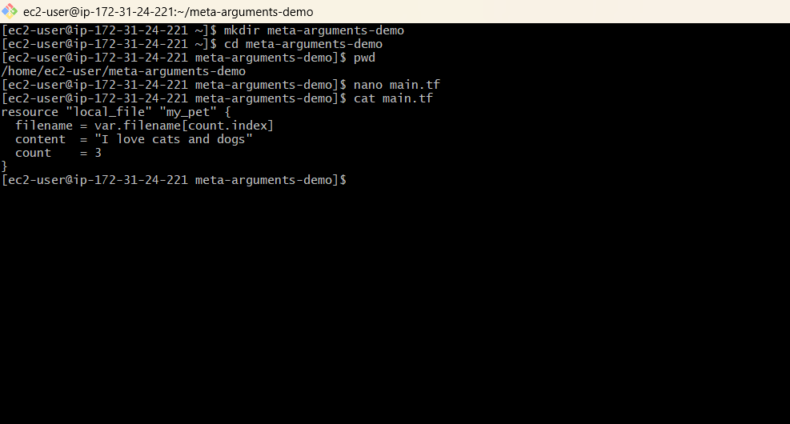
Create variable.tf
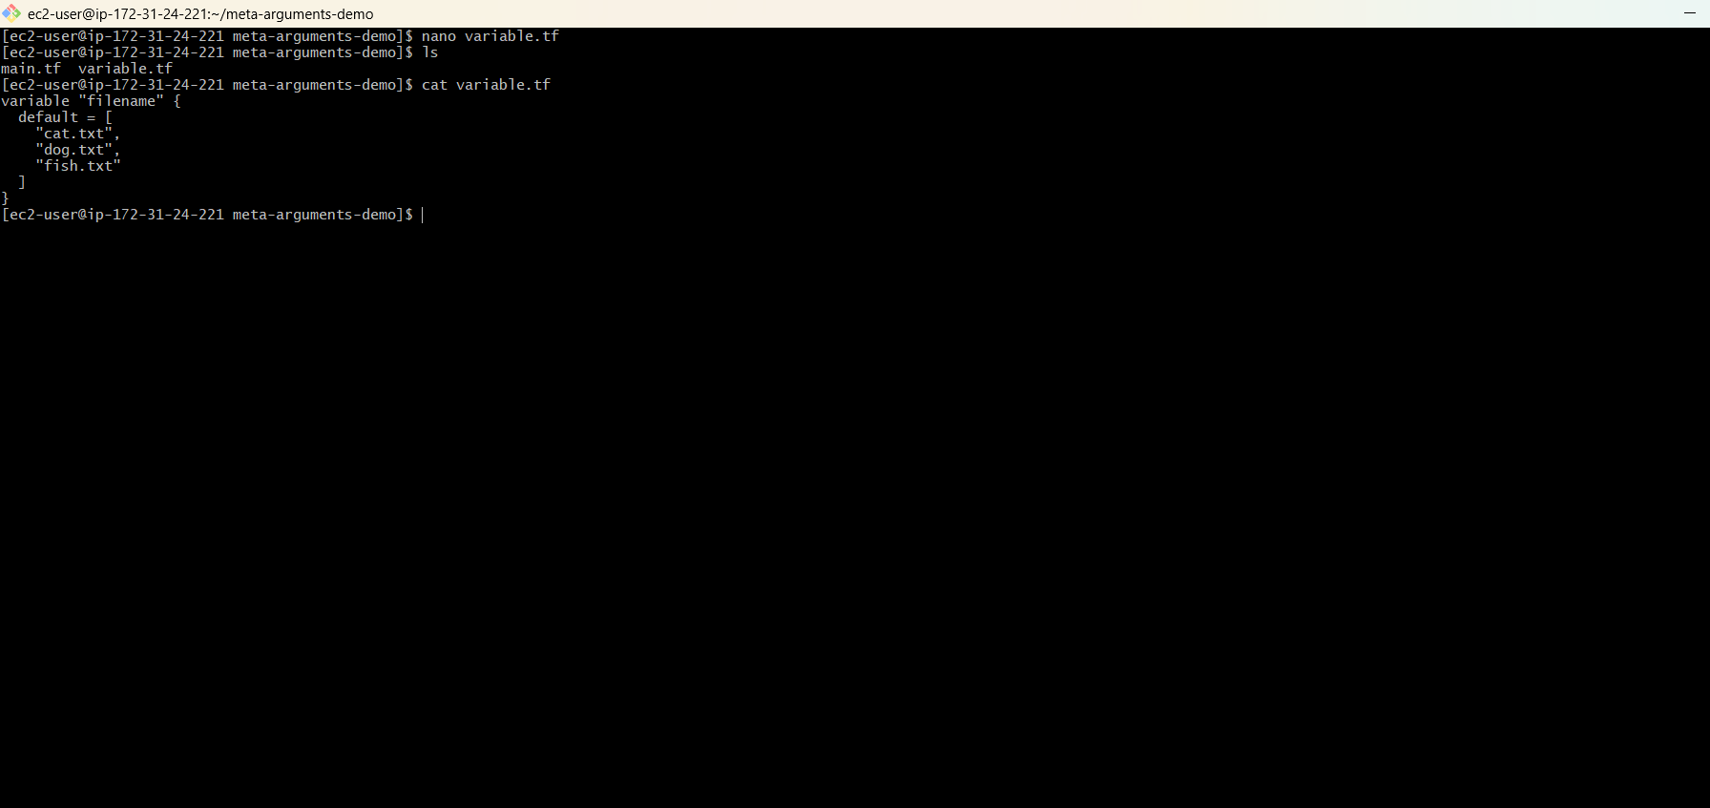
Step 4 — Initialize Terraform
In PowerShell:
terraform init 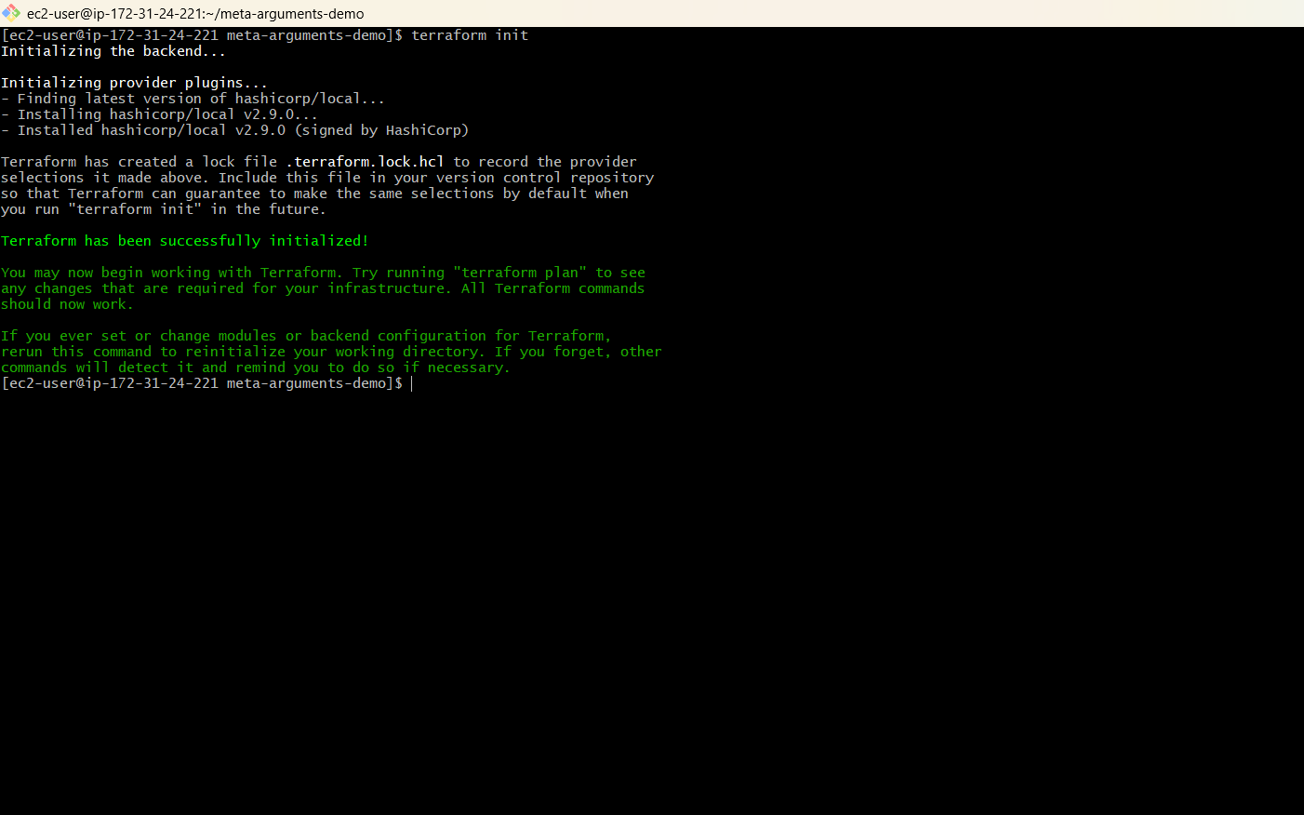
Step 5 — Check the plan
terraform plan
You should see:
Plan: 3 to add, 0 to change, 0 to destroy 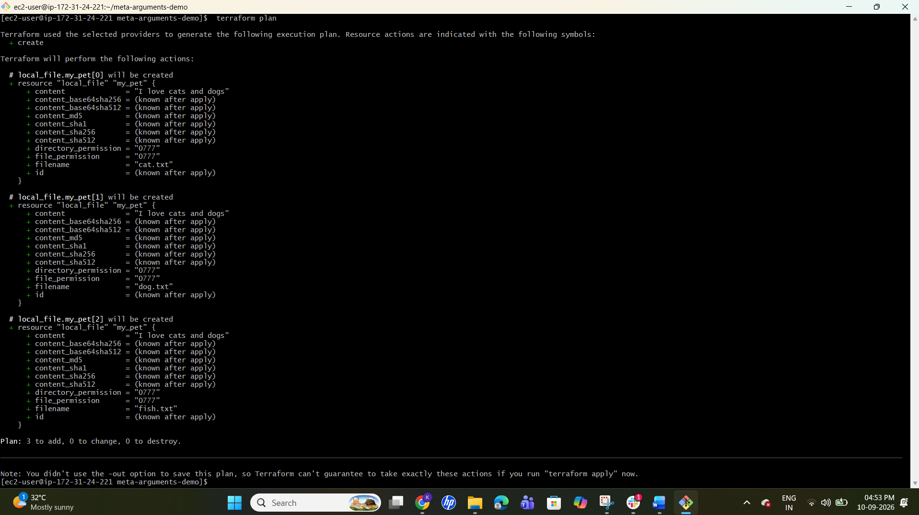
Step 6 — Apply
terraform apply
Type:
yes 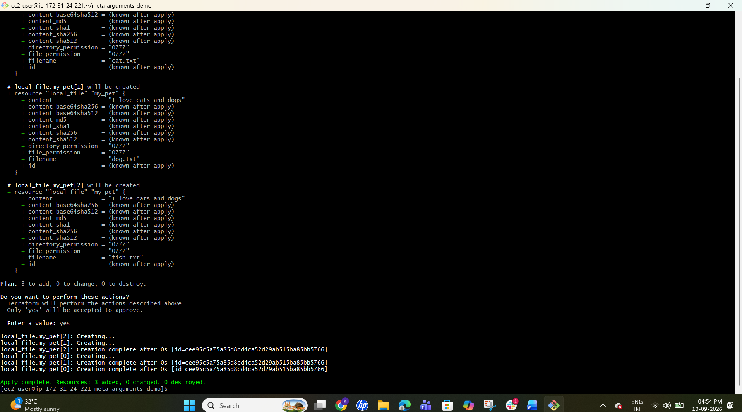
Step 7 — Check files
Get-ChildItem
You should have:
file-0.txt
file-1.txt
file-2.txt
main.tf
✅ count completed. 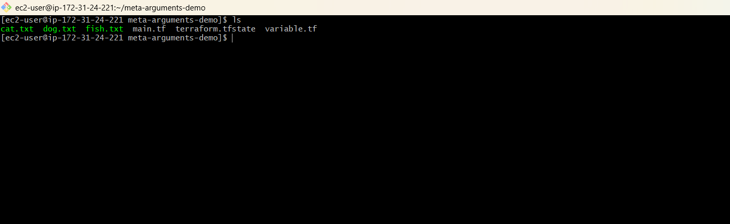

  - Dynamic Resource Creation Using length() ---best practice
1. variables.tf
variable "filename" {
default = ["dog.txt", "cat.txt", "fish .txt"]
}
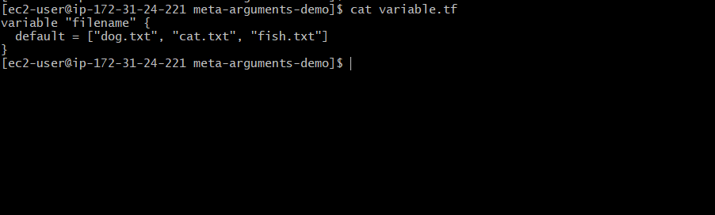

2. main.tf
resource "local_file" "file" {
count = length(var.filename)
filename = var.filename[count.index]
content = "I love cats and dogs"
} 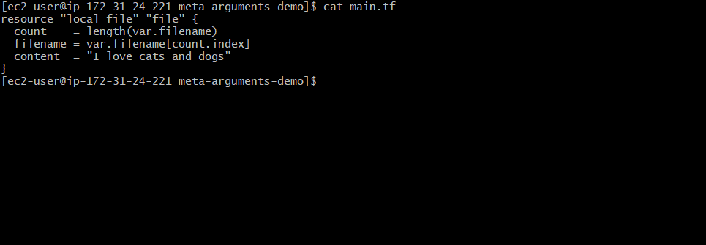
3. Run
terraform init
terraform plan
terraform apply 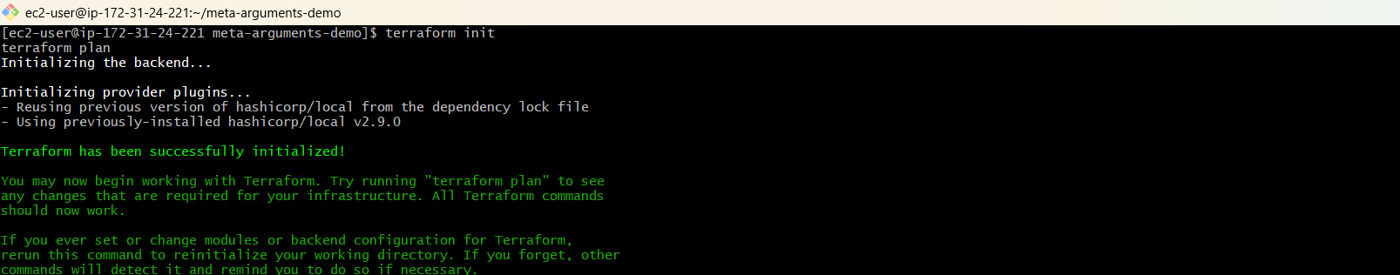
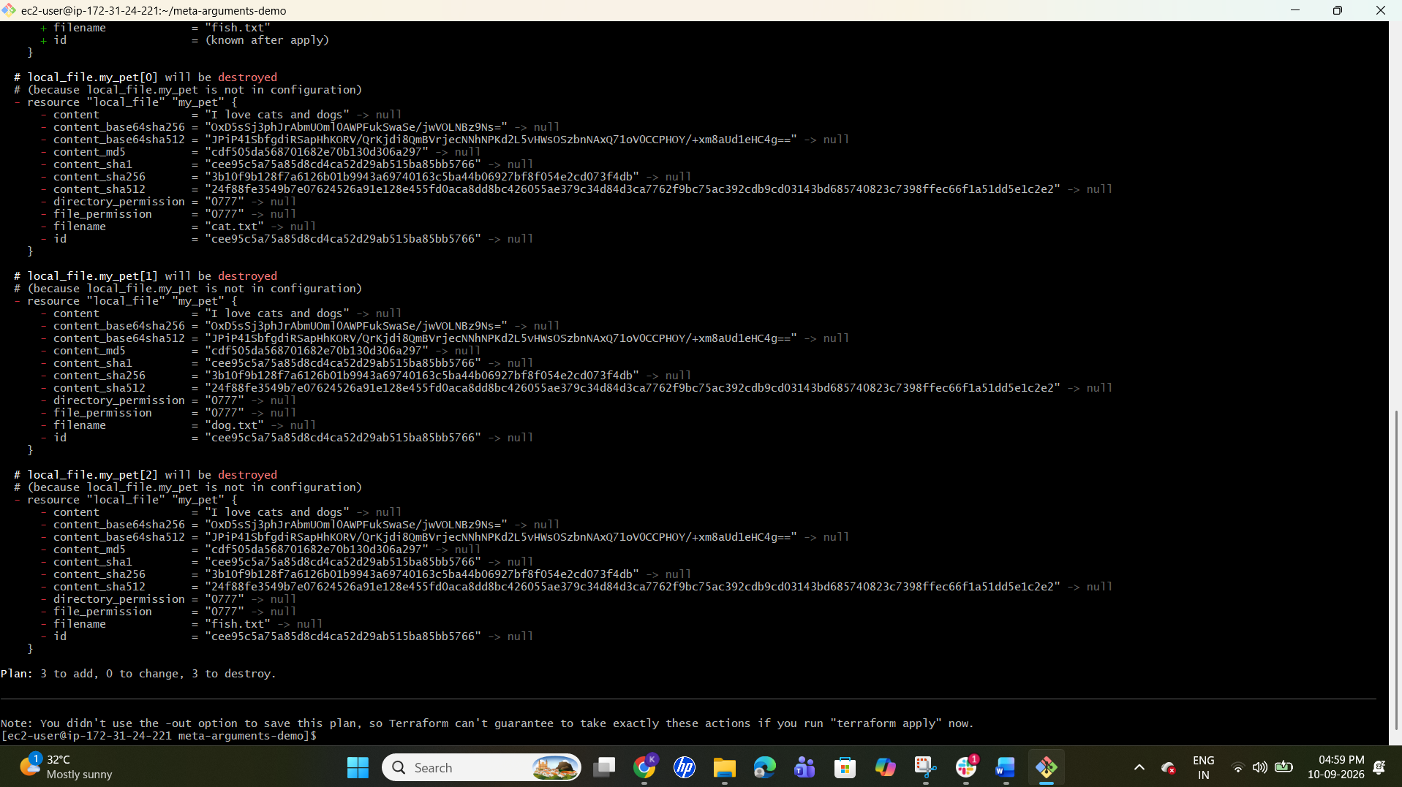
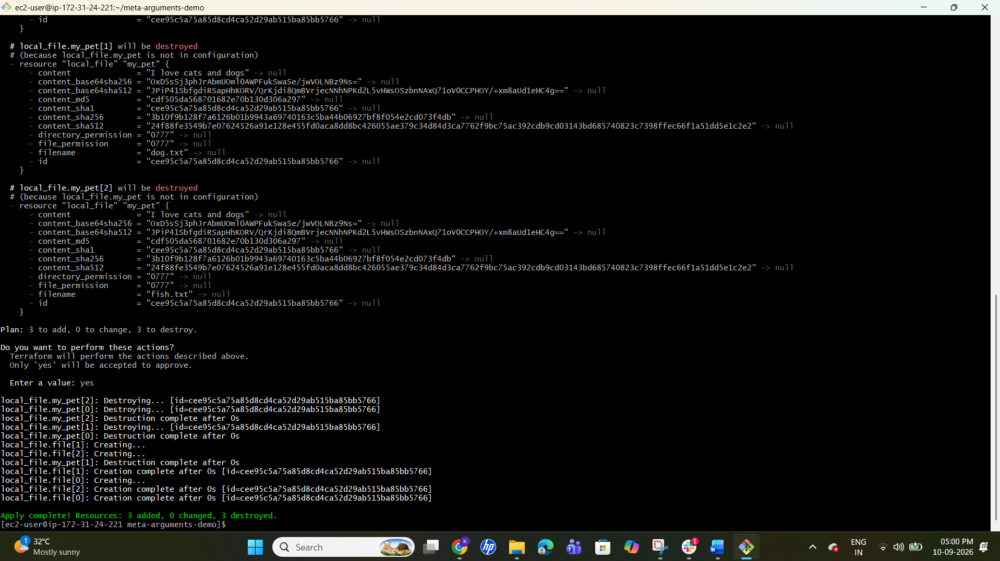

Meta Arguments
for_each
1. Create folder:
cd C:\Users\sriva\Desktop\Terraform-provider
mkdir for-each-demo
cd for-each-demo
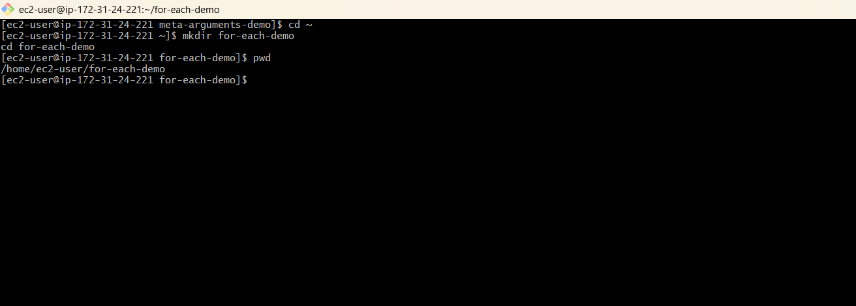
2. for_each.tf
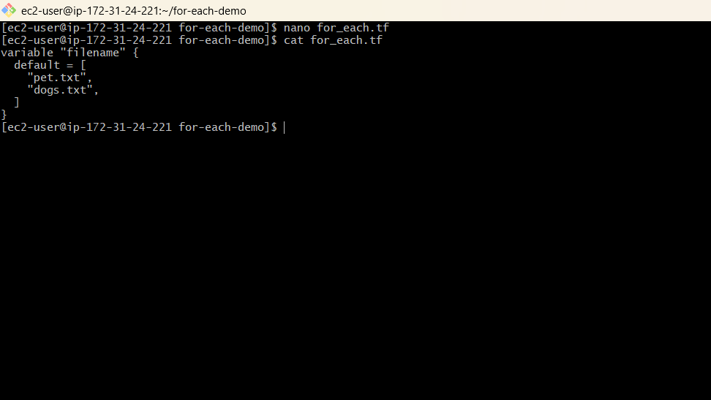
3. main.tf
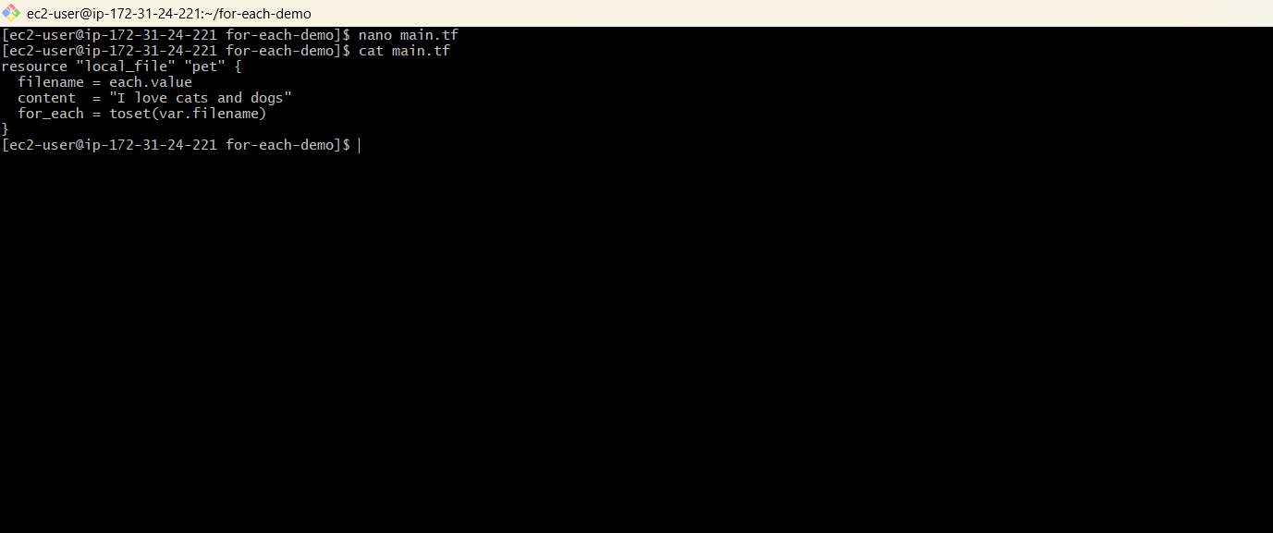

4. Run:
terraform init
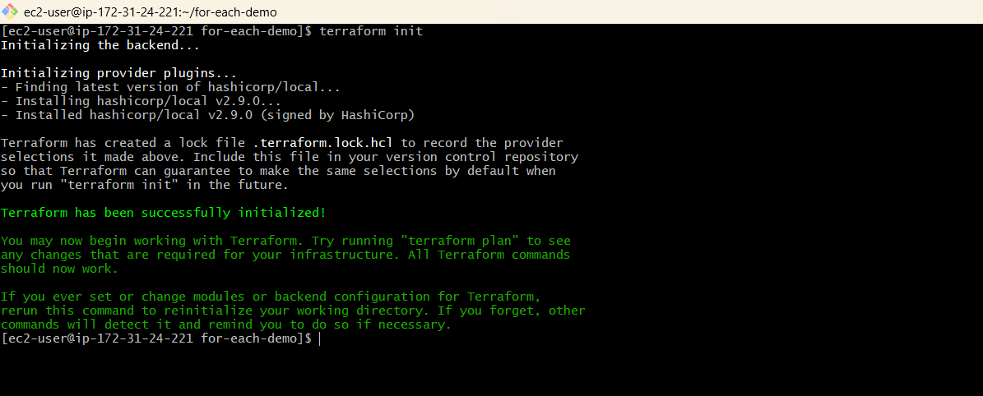
terraform plan
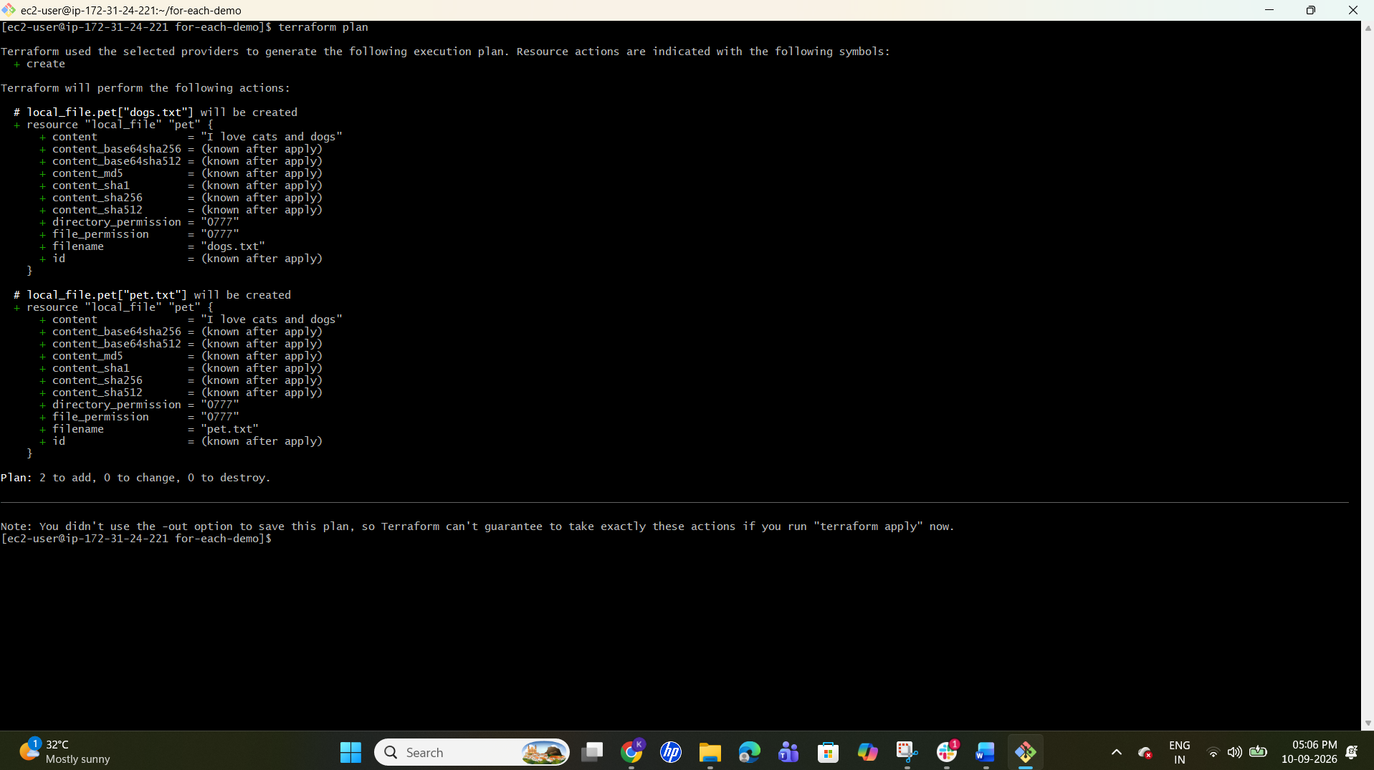
terraform apply
Type yes.
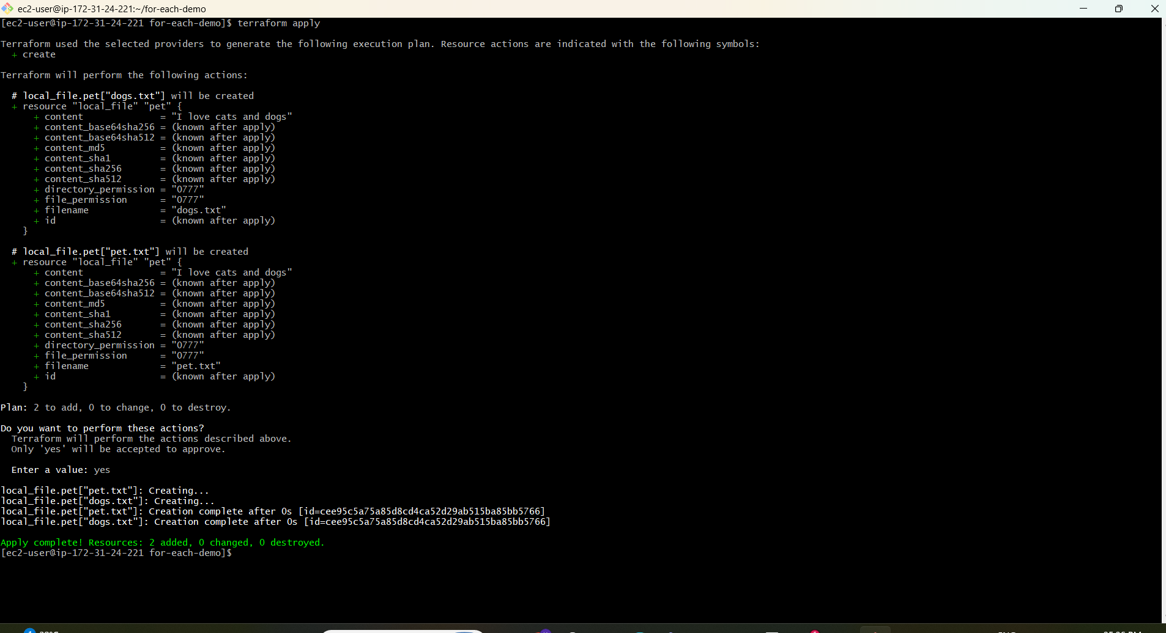
5. Result:
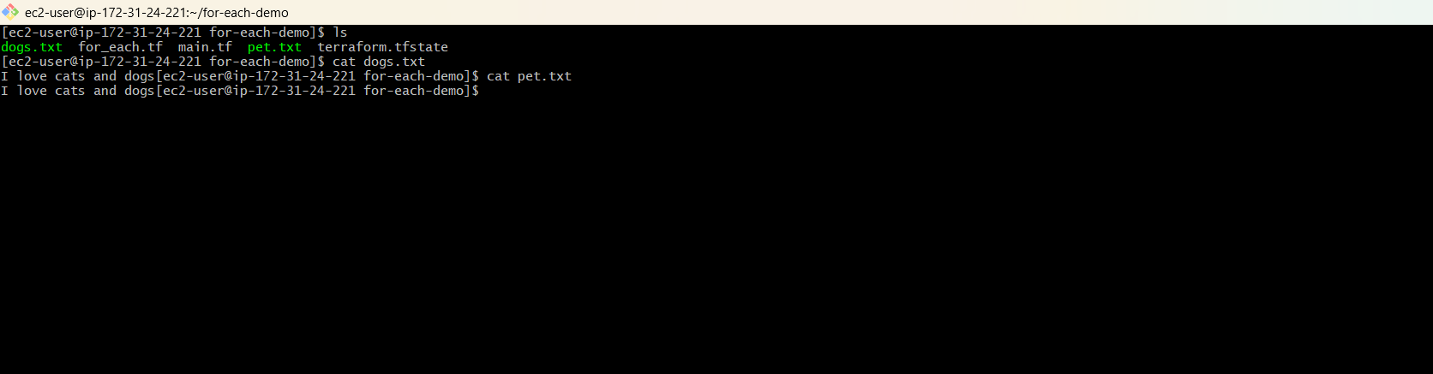

3). Integrate Terraform in Jenkins using the Terraform plugin.
Step 1 — Install Terraform Plugin
Jenkins → Manage Jenkins → Plugins → Available plugins
Search:
Terraform
Install it. 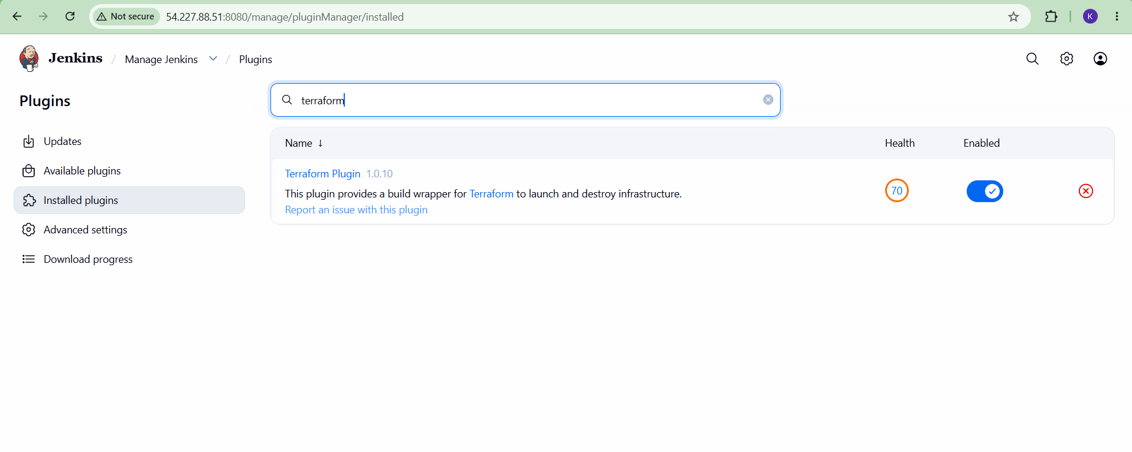

Step 2 — Configure Terraform
Jenkins → Manage Jenkins → Tools
Find Terraform installations → Add Terraform
Set:
Name: terraform
Install directory: /usr/bin
Select the Terraform version → Save. 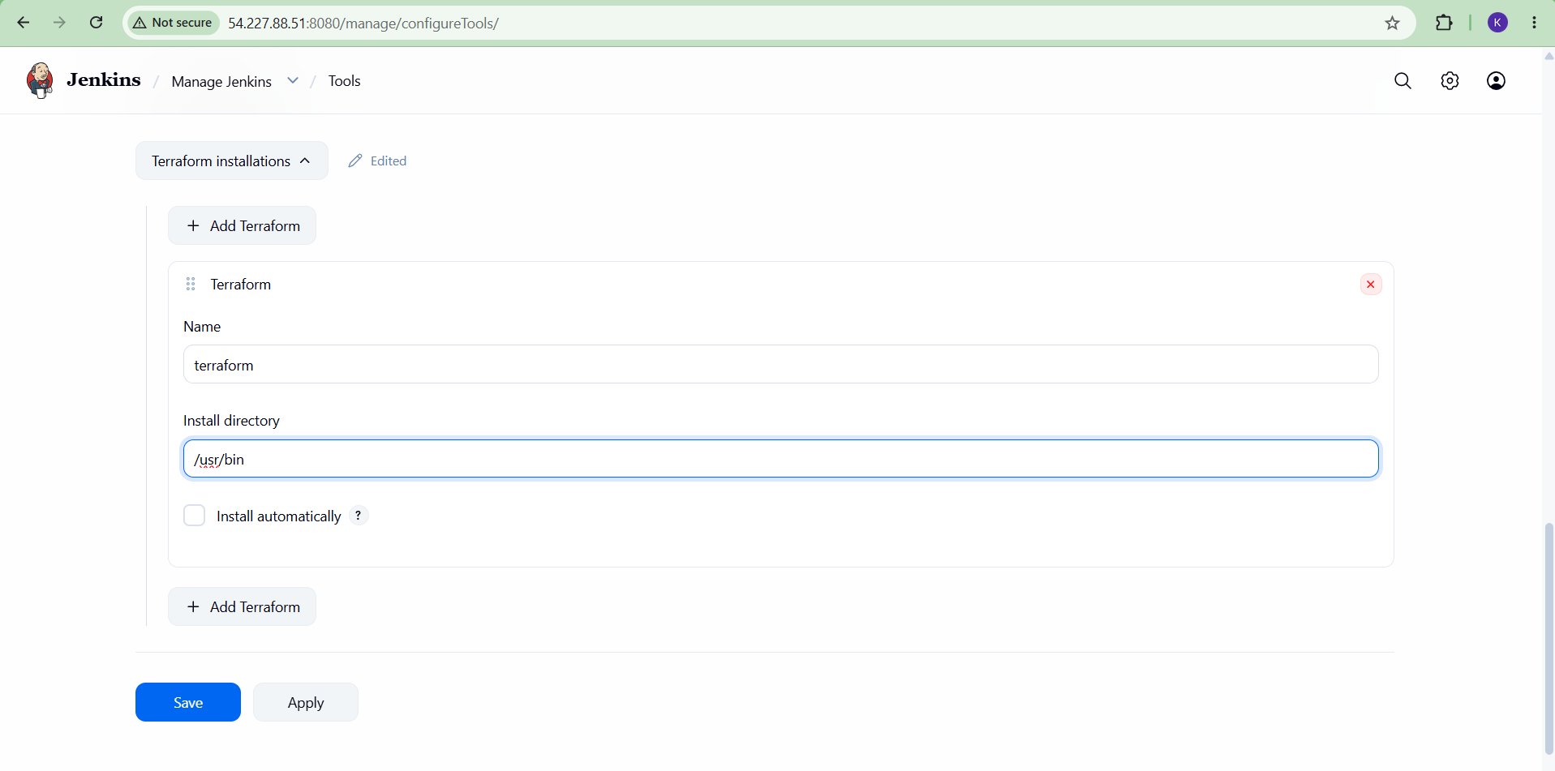

Step 3 — Create Terraform project in GitHub
Your repository should contain:
terraform-demo/
├── main.tf
└── variable.tf
Push the files to GitHub.
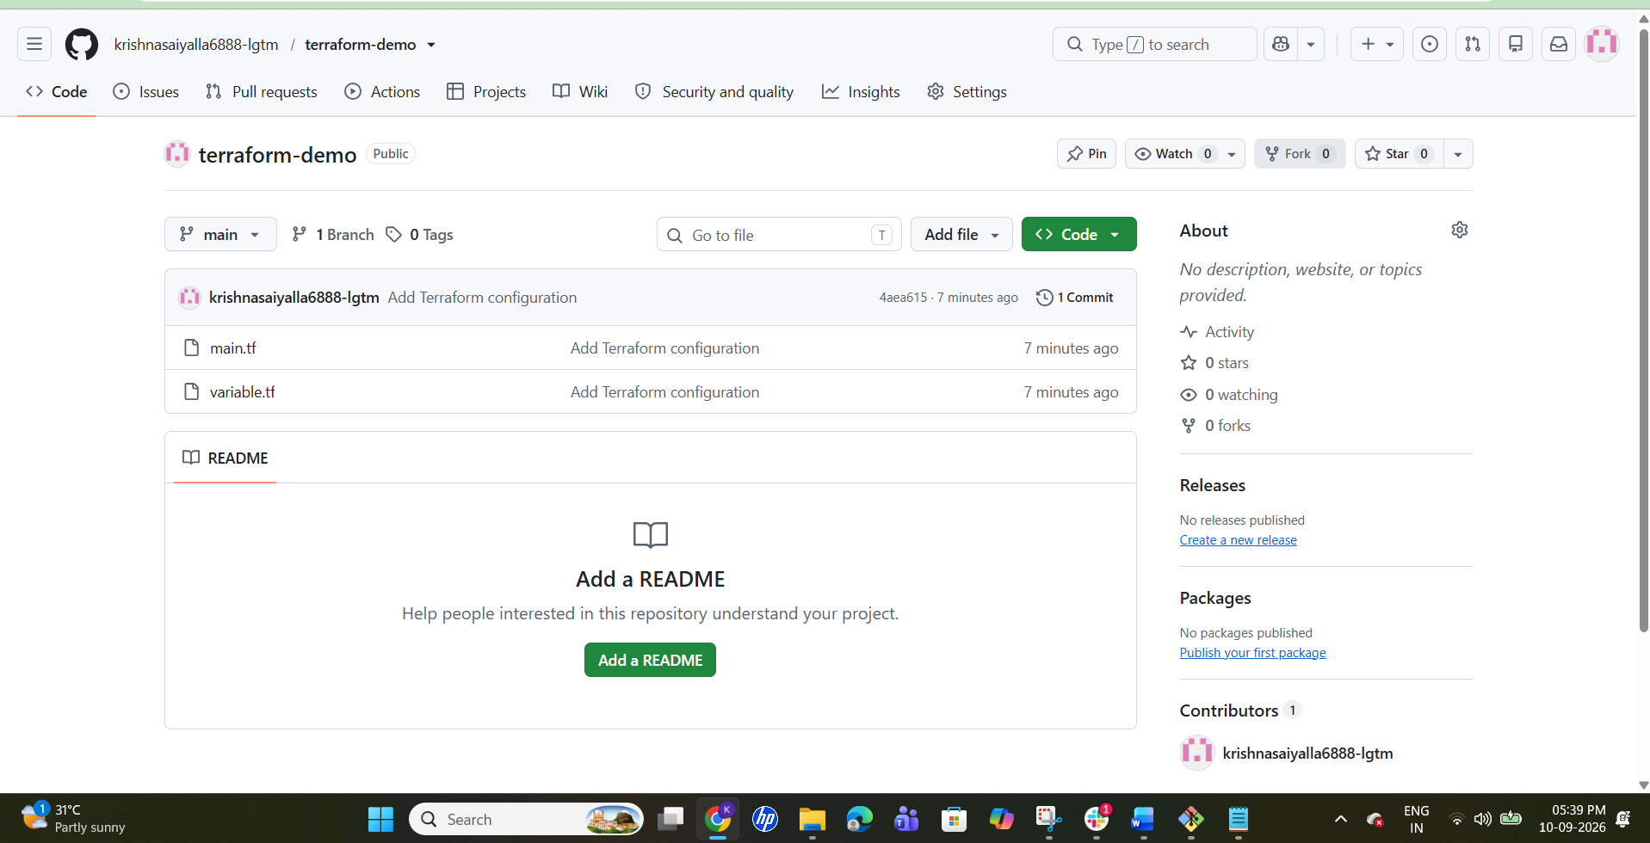

Step 4 — Create Jenkins Pipeline
Jenkins → New Item
Enter:
terraform-demo
Select Pipeline → OK. 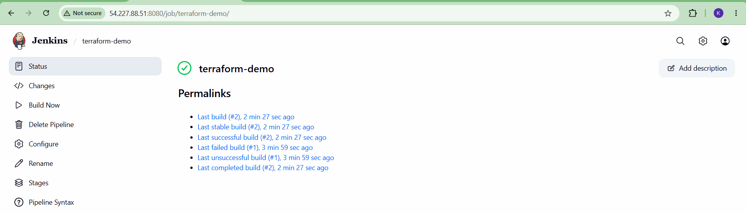

Step 5 — Add Pipeline Script
Go to: Pipeline → Definition → Pipeline script
pipeline {
agent any

stages {
stage('Git Clone') {
steps {
git branch: 'main',
url: 'https://github.com/krishnasaiyalla6888-lgtm/terraform-demo.git'
}
}

stage('Terraform Init') {
steps {
sh 'terraform init'
}
}

stage('Terraform Plan') {
steps {
sh 'terraform plan'
}
}

stage('Terraform Apply') {
steps {
sh 'terraform apply -auto-approve'
}
}
}
}

Step 6 — Run
Click:
Build Now 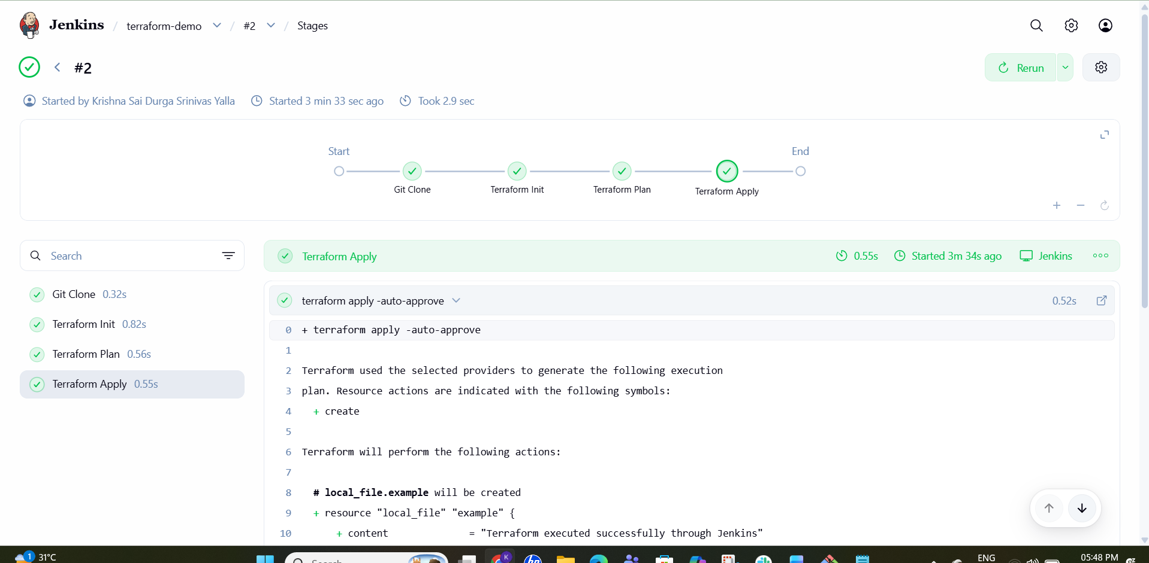
Then open:
Console Output
You should see:
Git Clone
↓
Terraform Init
↓
Terraform Plan
↓
Terraform Apply
↓
SUCCESS

4). Create a CI/CD pipeline for a Nodejs Application: https://github.com/betawins/Trading-UI.git
1. Install NodeJS plugin in Jenkins
Go to:
Jenkins → Manage Jenkins → Plugins → Available plugins
Search:
NodeJS
Install NodeJS Plugin.
This plugin lets Jenkins configure a Node.js installation and put node/npm on the PATH for pipeline steps. 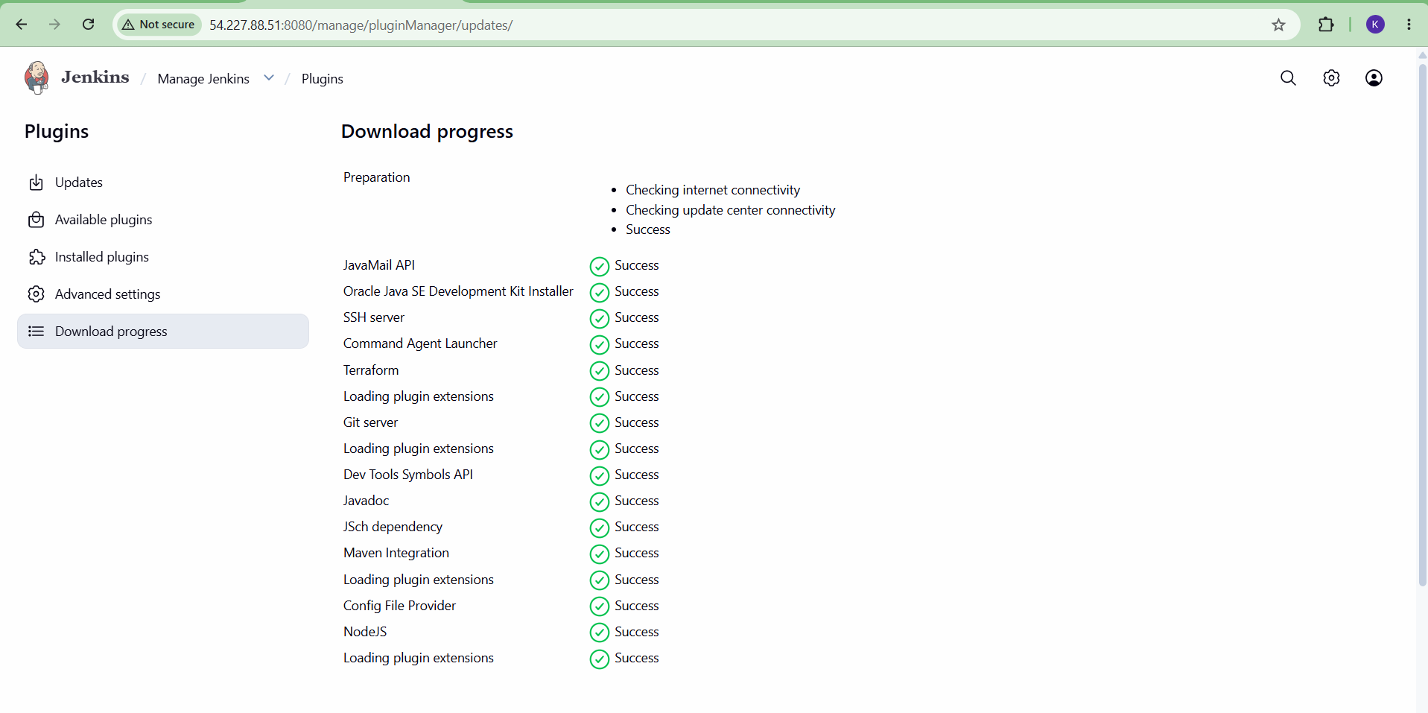

2. Configure Node.js
Go to:
Manage Jenkins → Tools → NodeJS installations
Click:
Add NodeJS
Use:
Name: NodeJS
Install automatically: ✓
Version: Node.js 20.x
Click Save. 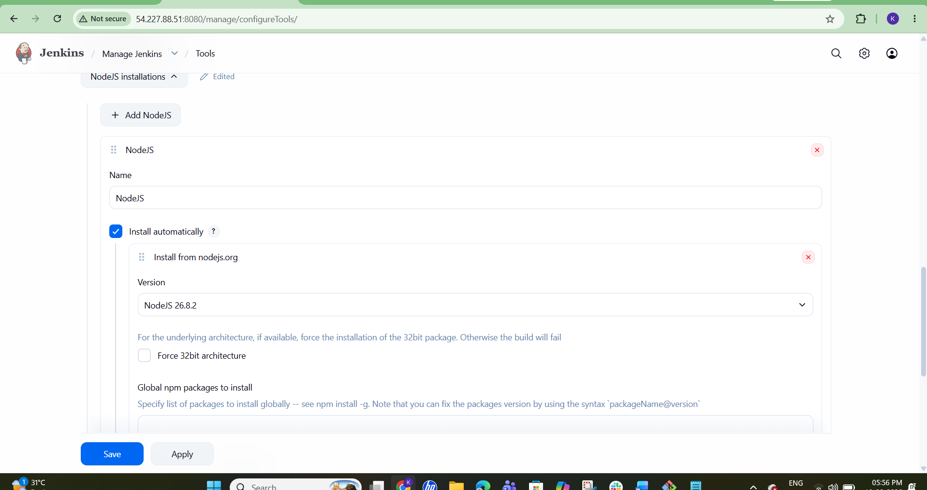

3. Create Jenkins Pipeline
Jenkins:
Dashboard → New Item
Name:
Trading-UI-CICD
Select:
Pipeline
Click OK. 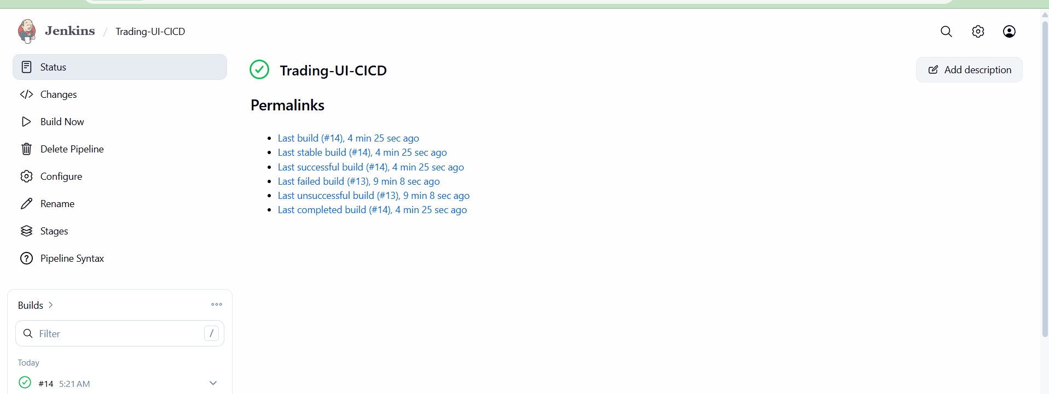

4. Use this Jenkinsfile
pipeline {
agent any

tools {
nodejs 'NodeJS'
}

environment {
NODE_OPTIONS = '--openssl-legacy-provider'
}

stages {

stage('Git Clone') {
steps {
git branch: 'master',
url: 'https://github.com/betawins/Trading-UI.git'
}
}

stage('Install Dependencies') {
steps {
sh 'npm install'
}
}

stage('Build') {
steps {
sh 'CI=false npm run build'
}
}

stage('Test') {
steps {
sh 'CI=false npm test -- --watchAll=false --runInBand --forceExit --testPathIgnorePatterns="Purchase.test.js"'
}
}

stage('Deploy') {
steps {
sh '''
sudo rm -rf /usr/share/nginx/html/*
sudo cp -r build/* /usr/share/nginx/html/
sudo systemctl restart nginx
'''
}
}
}
}
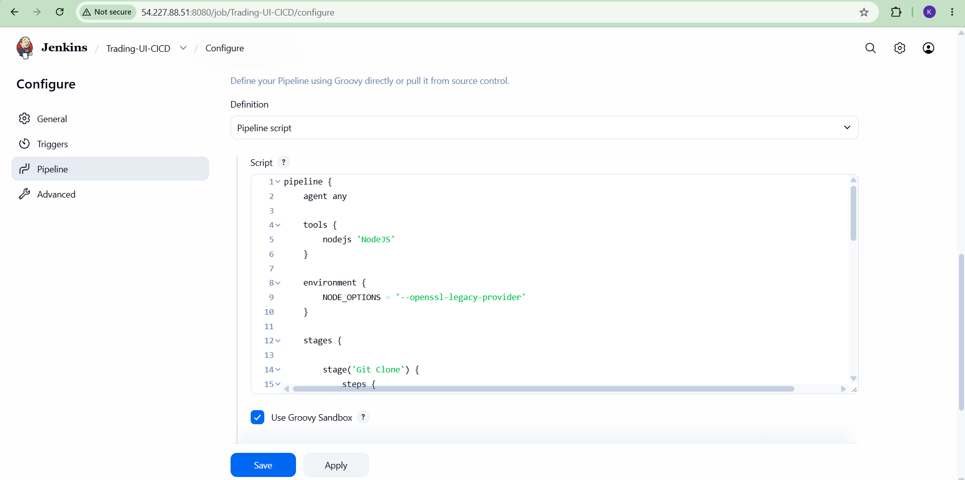
This tells Jenkins to use the NodeJS installation you configured.

5. Jenkins Pipeline configuration
In the Pipeline section select:
Definition: Pipeline script
Paste the Jenkinsfile above.
Click:
Save → Build Now
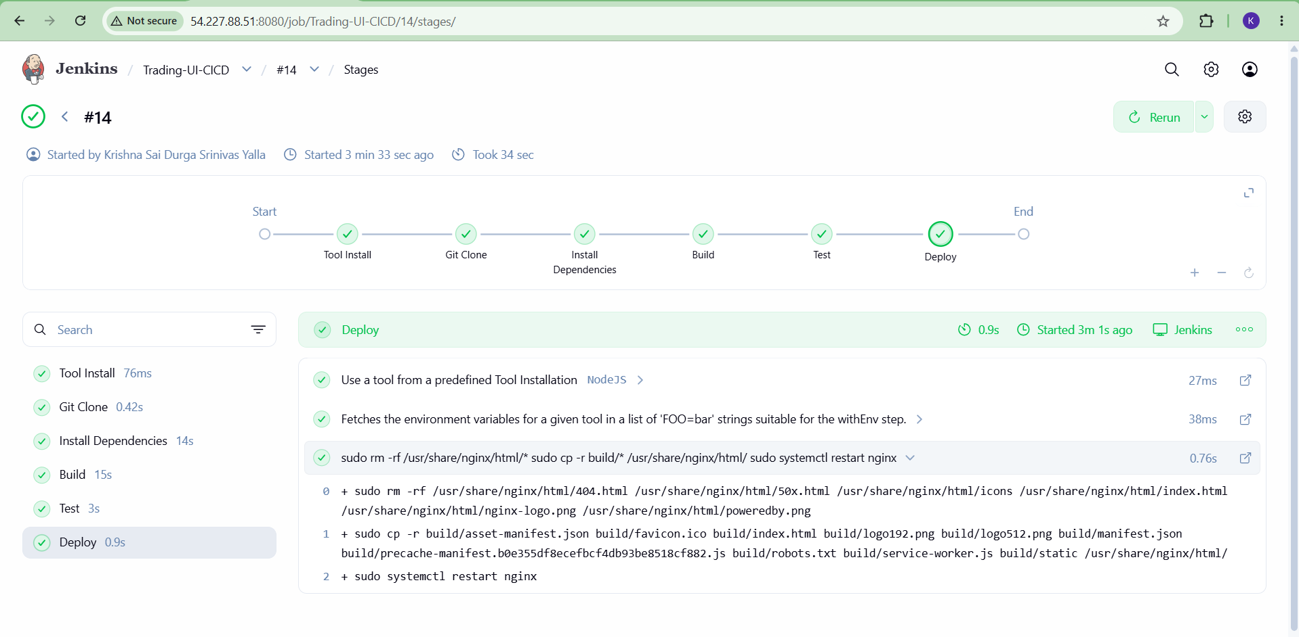

6. Pipeline flow
You should see:
Git Clone
↓
Install Dependencies
↓
Build
↓
Test
↓
deploy

  - 5). Explain 10 Maven commands.
0 important Maven commands explained simply, with DevOps/interview perspective:
# | Maven Command | Purpose
1 | mvn clean | Deletes the target/ directory
2 | mvn compile | Compiles the source code
3 | mvn test | Runs unit tests
4 | mvn package | Creates JAR/WAR after compiling and testing
5 | mvn install | Installs the JAR/WAR into local Maven repository
6 | mvn deploy | Uploads artifact to a remote repository like Nexus
7 | mvn validate | Checks whether the project is correct
8 | mvn verify | Performs checks to ensure the package is valid
9 | mvn dependency:tree | Shows project dependencies
10 | mvn clean package | Cleans old build and creates a new JAR/WAR
1. mvn clean
mvn clean
Deletes the previous target/ directory.
Use: Before doing a fresh build.

2. mvn compile
mvn compile
Compiles Java source code.
Example:
src/main/java
↓
compile
↓
target/classes

3. mvn test
mvn test
Runs unit tests.
Example:
Compile → Test
If a test fails, Maven normally stops here.

4. mvn package
mvn package
Creates the application package.
For a Java application:
target/myapp.jar
For a web application:
target/myapp.war
It also runs tests by default.

5. mvn install
mvn install
Builds the project and stores the generated artifact in the local Maven repository.
Usually:
~/.m2/repository/
Flow:
Compile → Test → Package → Install locally

6. mvn deploy
mvn deploy
Uploads the generated artifact to a remote repository, such as Nexus or Artifactory.
Typical CI/CD flow:
Git
↓
Maven Build
↓
mvn deploy
↓
Nexus / Artifactory

7. mvn validate
mvn validate
Checks that the Maven project is correctly configured.
For example, it checks the basic pom.xml structure.

8. mvn verify
mvn verify
Runs additional checks after packaging to verify that the build is valid.
Simplified:
Compile → Test → Package → Verify

9. mvn dependency:tree
mvn dependency:tree
Shows all dependencies used by your application.
Example:
myapp
├── spring-core
├── spring-web
└── mysql-connector
Very useful for troubleshooting dependency conflicts.

10. mvn clean package
mvn clean package
This is very commonly used in Jenkins.

